LTO Appendix J – Spring Delta Outflow

Attachment J, Hennessy and Burris

This page intentionally left blank

# Hennessy and Burris: Zooplankton Flow Relationships

## Model Overview

Zooplankton are an importance food source for many juvenile and small pelagic fish in the Bay-Delta. Delta Smelt and Longfin Smelt are two species that rely on zooplankton. The abundance of zooplankton species was examined in relationship to freshwater outflow in the upper San Francisco Estuary: the calanoid copepod *Eurytemora affinis*, the mysid shrimp *Neomysis mercedis*, and the calanoid copepod *Pseudodiaptomus forbesi.* This analysis was presented using data through 2015 in a CDFW Memorandum (Hennessy and Burris, 2017) and an updated analysis is presented using data through 2022.

Kimmerer (2002) reported spring abundance of *E. affinis* abundance only became correlated with flow after the 1986 invasive clam invasion. The relationship of *N. mercedis* and outflow also changed post clam invasion, summer abundance increases with low outflows (Kimmerer 2002).

Results demonstrate the relationship between abundance of smelt prey in the Delta and outflow, controlled by CVP and SWP seasonal operations.

## Model Development

### Methods

Biological Data: The biological data used for this analysis were collected as part of the CDFW Zooplankton Study ([www.wildlife.ca.gov/Conservation/Delta/Zooplankton-Study](http://www.wildlife.ca.gov/Conservation/Delta/Zooplankton-Study)). The Zooplankton Study provides annual zooplankton abundance indices using monthly sampling conducted between January and December at 19 discreet stations (1972 – 2022). Information on data for each species is in Table 1. For each month and year, CPUE was averaged from specific stations by month, and monthly means were averaged to get an annual abundance. Abundance data were transformed to normalize residuals (Table 2).

Hydrologic Data: Daily Delta outflow (cfs) used for this analysis was obtained from DWR (<http://www.water.ca.gov/dayflow/output/>). For each month and year, mean outflows were calculated for each month, and monthly means were averaged over the determined time frame for each species to get an annual value. Hydrologic data were transformed (Table 2).

Relationship Development: A single relationship was developed for outflow with each species using least squares linear regressions (Table 2): transformed outflow as the explanatory variable for transformed zooplankton species abundance. Additional relationships were developed [by water year type] / [by sub time frame] – to help match with implementation?

Implementation to Alternatives: Developed relationships were applied to …

Table 1. Time frames, life stages, stations, and sampling methods used in analyses.

| Species | Time Frame | Life Stage | Stations | Sampling Method |
| --- | --- | --- | --- | --- |
| *E. affinis* | March – June  1994 – 2022, monthly |  | Entrapment zone:  NZEZ2 and NZEZ6 | Modified Clarke-Bumpus (CB) net (160-micron mesh) |
| *N. mercedis* | March – May  1994 – 2022, monthly |  | Entrapment zone:  NZEZ2 and NZEZ6 | Mysid shrimp net (505-micron mesh) |
| *P. forbesi* | June – September  1989 - 2022, monthly |  | Suisun Bay  (NZ020, 022, 024, 028, 030, 036, 038, 040, 042, 044, 046, 048, 050, 052, 054) | Modified Clarke-Bumpus (CB) net (160-micron mesh) |

Table 2. Data transformations used in analyses and species-specific regression equations.

| Species | Outflow Transformation | Species Transformation | Regression |
| --- | --- | --- | --- |
| *E. affinis* |  |  |  |
| *N. mercedis* |  |  |  |
| *P. forbesi* |  |  |  |

### Assumptions / Uncertainty

Needs to be developed.

### Code and Data Repository

Biological data can be found online at [www.wildlife.ca.gov/Conservation/Delta/Zooplankton-Study](http://www.wildlife.ca.gov/Conservation/Delta/Zooplankton-Study) and on the ICF SharePoint in the Data and Code folder ([Data and Code](https://icfonline.sharepoint.com/:f:/r/sites/EP/USBR_2021LTO/Public%20Draft%20Alternatives/Appendix%20J.%20Spring%20Delta%20Outflow%20Attachments/J.%20SpringDeltaOutflow%20Hennessy%20and%20Burris%20-%20DECIDED_AGAINST/Data%20and%20Code?csf=1&web=1&e=TNxISv)).

Hydrologic data can be found online at <http://www.water.ca.gov/dayflow/output/> and on the ICF SharePoint in the Data and Code folder ([Data and Code](https://icfonline.sharepoint.com/:f:/r/sites/EP/USBR_2021LTO/Public%20Draft%20Alternatives/Appendix%20J.%20Spring%20Delta%20Outflow%20Attachments/J.%20SpringDeltaOutflow%20Hennessy%20and%20Burris%20-%20DECIDED_AGAINST/Data%20and%20Code?csf=1&web=1&e=TNxISv)).

R code can be found on the ICF SharePoint in the Data and Code folder ([Data and Code](https://icfonline.sharepoint.com/:f:/r/sites/EP/USBR_2021LTO/Public%20Draft%20Alternatives/Appendix%20J.%20Spring%20Delta%20Outflow%20Attachments/J.%20SpringDeltaOutflow%20Hennessy%20and%20Burris%20-%20DECIDED_AGAINST/Data%20and%20Code?csf=1&web=1&e=TNxISv)).

## Results

* figures of transformed data for full time frame (CPUE E. affinis | outflow) & (CPUE N. mercedis | outflow)
* same raw data in figures for sub time frame or by water year type
* some results on “implementation to alternatives” (table? figure?)

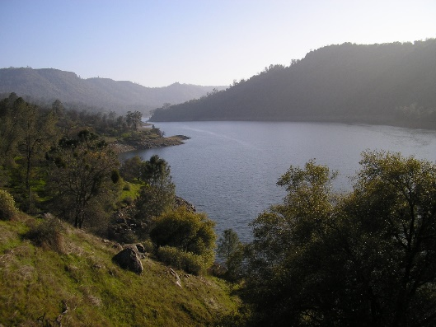

Figure 1. Mean abundance (CPUE) by mean Delta outflow (cfs) for *E. affinis* from March through June annually from 1994 – 2022.



Figure 2. Mean abundance (CPUE) by mean Delta outflow (cfs) for *N. mercedis* from March through May annually from 1994 – 2022.



Figure 3. Mean abundance (CPUE) by mean Delta outflow (cfs) for *P. forbesi* from June through September annually from 1989 – 2022.

## References

Hennessy, A. and Burris, Z. 2017. Memorandum: Preliminary analysis of current relationships between zooplankton abundance and freshwater outflow in the upper San Francisco Estuary. California Department of Fish and Wildlife, 8 pages.

Kimmerer, W. J. 2002. Effects of freshwater flow on abundance of estuarine organisms: physical effects or trophic linkages? Marine Ecology Progress Series, 243, 39-55.